Electric Motor Temperature Prediction System
VISHNU INSTITUTE OF TECHNOLOGY- VITB, Bhimavaram

Team ID: LTVIP2026TMIDS78786
Team Members Details:
S.No | Name of the Student
1 | Alladi Johnpaul
2 | D V Pravallika
3 | Bodaballa Jaswanth
4 | Mahammad Adhil

AI&ML Project Documentation

Project Title:
Electric Motor Temperature Prediction System Using Machine Learning

Project Description:
This project aims to predict the temperature of an electric motor using Machine Learning techniques to improve operational safety and efficiency. Overheating in electric motors can lead to reduced performance, equipment damage, and increased maintenance costs.
The system analyzes sensor data such as voltage, current, torque, speed, and ambient conditions to predict motor temperature in real time. By leveraging predictive analytics, the application enables early detection of abnormal temperature rise and supports preventive maintenance decisions.
The solution automates temperature prediction, reduces manual monitoring efforts, and enhances reliability through data-driven insights.

Project Objectives:
- Develop a machine learning model to predict electric motor temperature
- Analyze sensor-based operational parameters affecting motor performance
- Reduce risk of motor failure through early prediction
- Improve maintenance planning using predictive analytics
- Automate data preprocessing and model evaluation
- Visualize prediction results for better understanding
- Enhance system reliability and operational efficiency

Project Features:
- Machine learning-based temperature prediction
- Data preprocessing and feature engineering
- Training and testing using real-world motor sensor datasets
- Model performance evaluation using regression metrics
- Visualization of temperature trends and predictions
- Automated prediction workflow
- Graphical insights using data visualization tools
- Accurate and scalable predictive system

Project Flow & Milestones:

1. Dataset Collection
Collected electric motor sensor data containing operational parameters such as voltage, torque, speed, and environmental conditions.

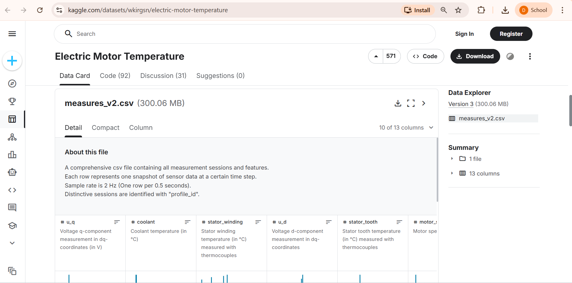

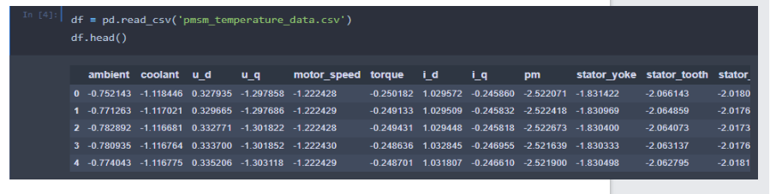

2. Data Preprocessing

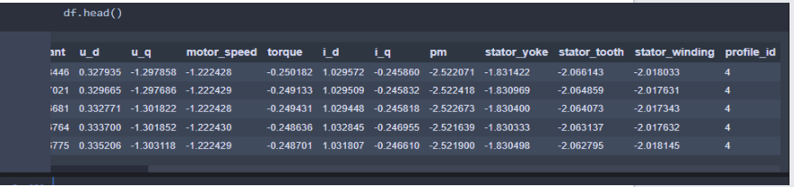

Performed:
- Handling missing values
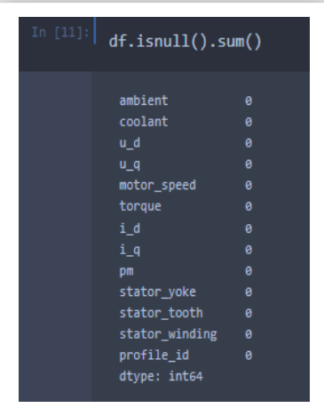

- Data cleaning and normalization
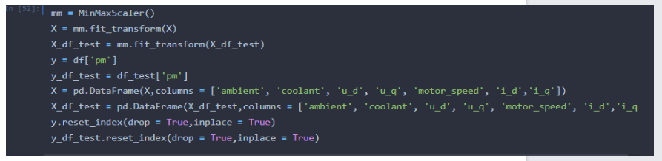
- Feature selection and transformation
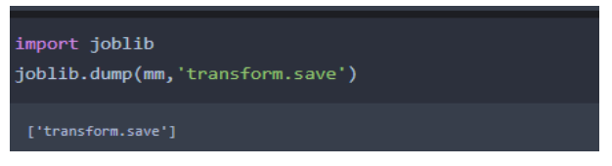
3. Exploratory Data Analysis (EDA)
Analyzed relationships between variables using:
- Correlation analysis
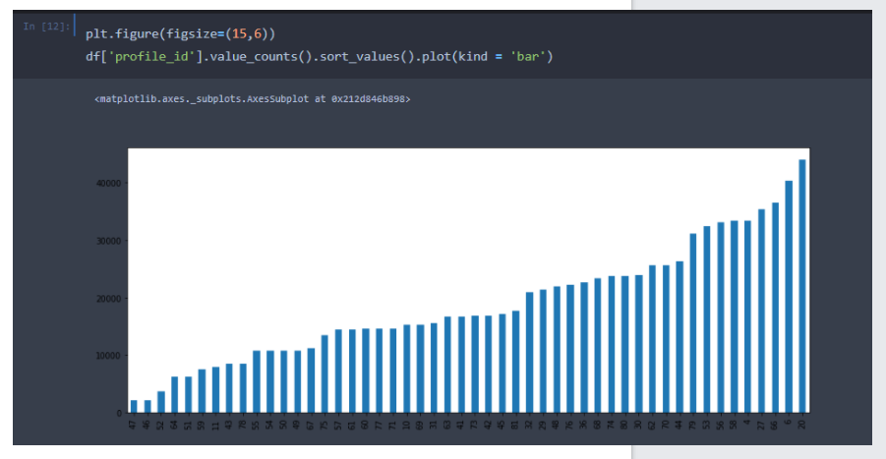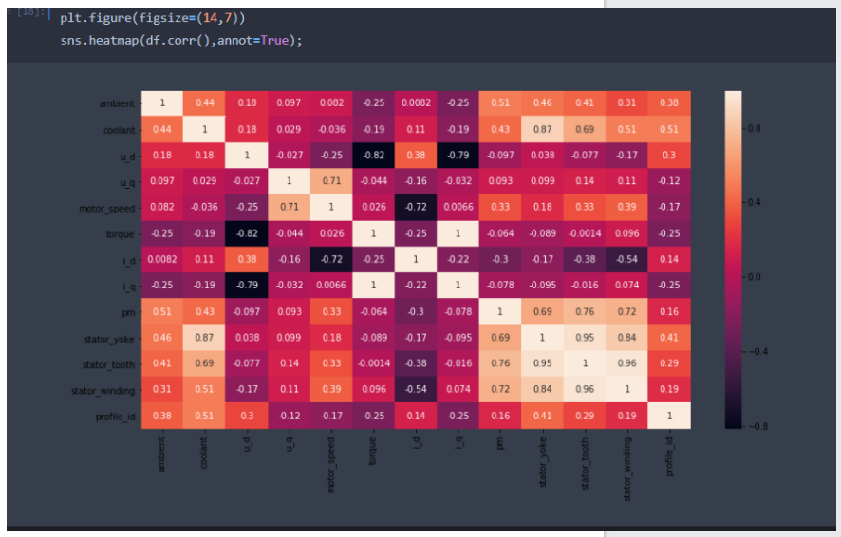

- Distribution plots
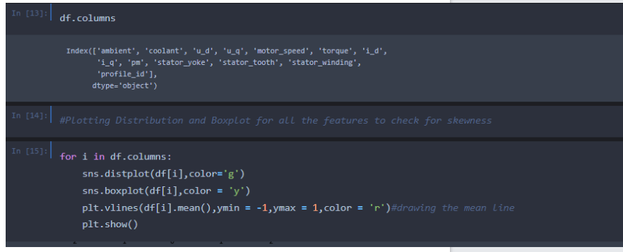
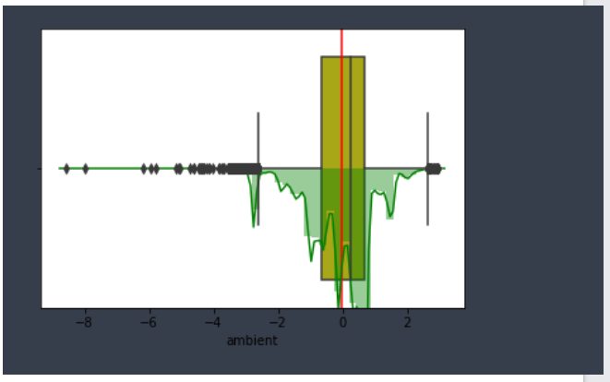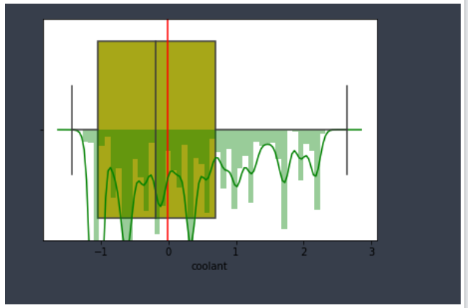
- Trend visualization
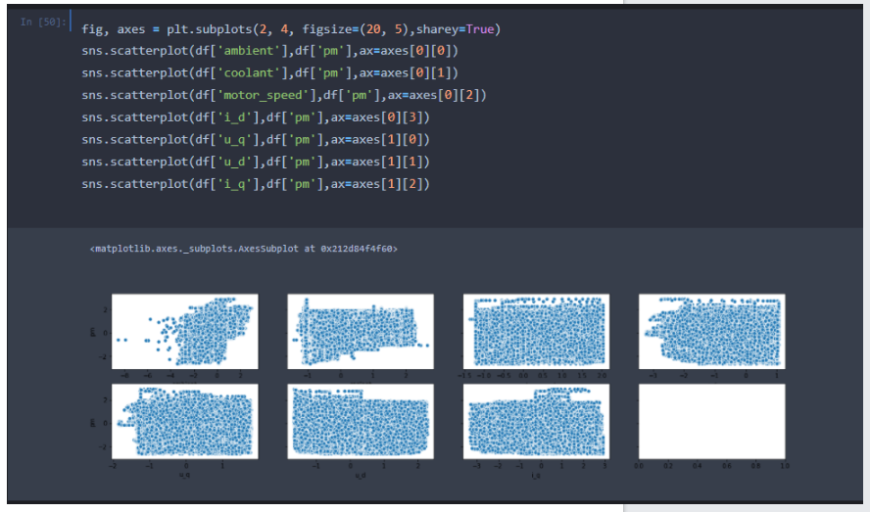

4.Model Development & Training
Implemented machine learning regression models to predict motor temperature.
Trained the model using historical sensor data and optimized parameters for improved accuracy.
cing motor temperature and prepared training datasets.

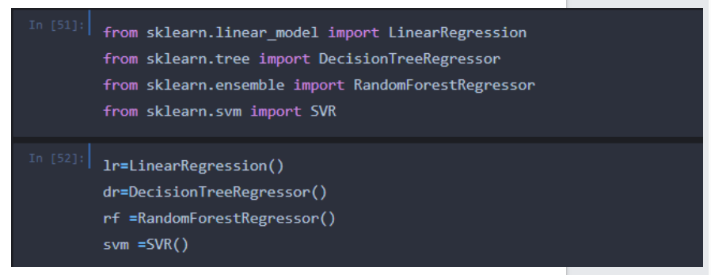
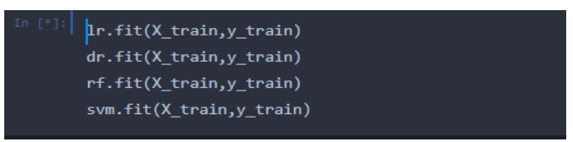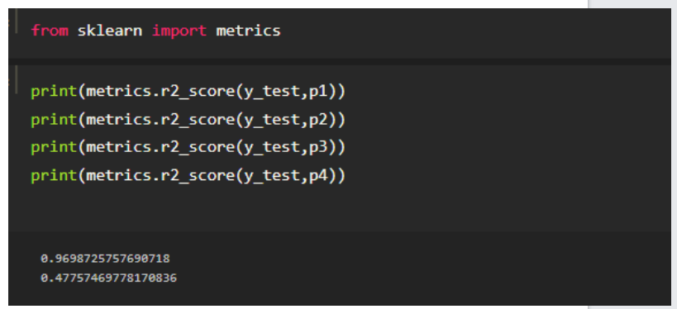
6. Model Evaluation
Evaluated performance using:
- Mean Squared Error (MSE)
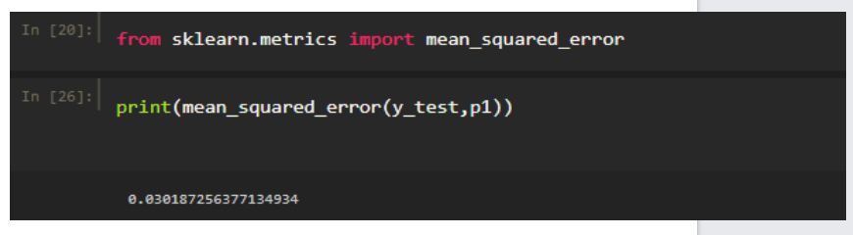
7. Prediction System
Built a system capable of predicting motor temperature based on new input sensor values.
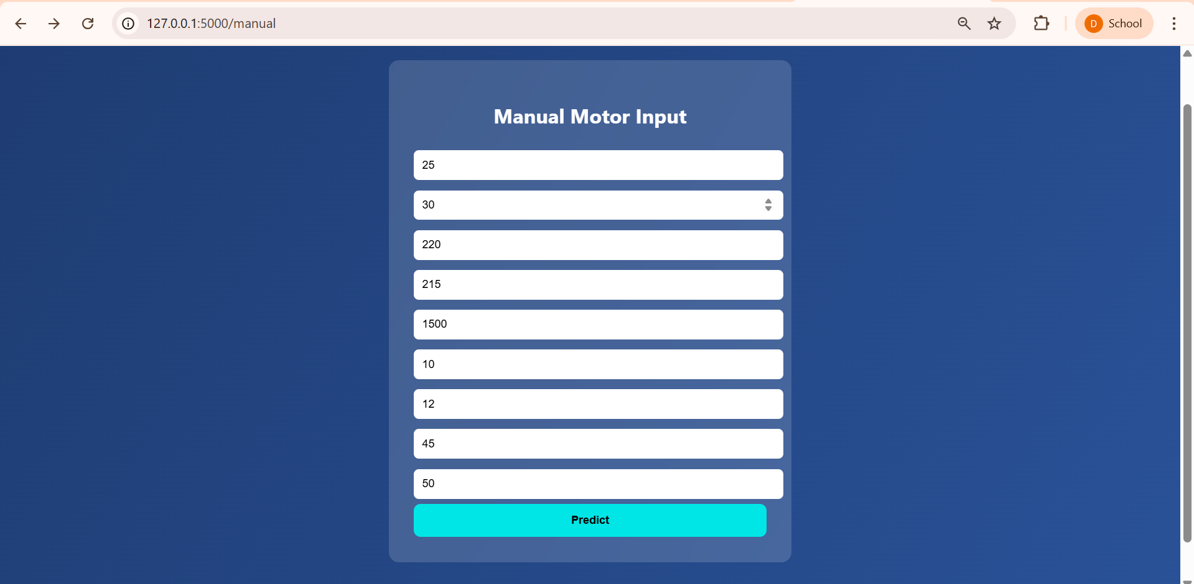

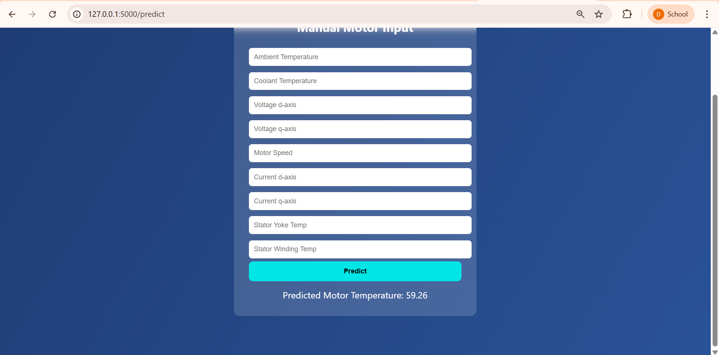

8 Final Output

A predictive analytics system that estimates electric motor temperature and assists in proactive maintenance decisions.

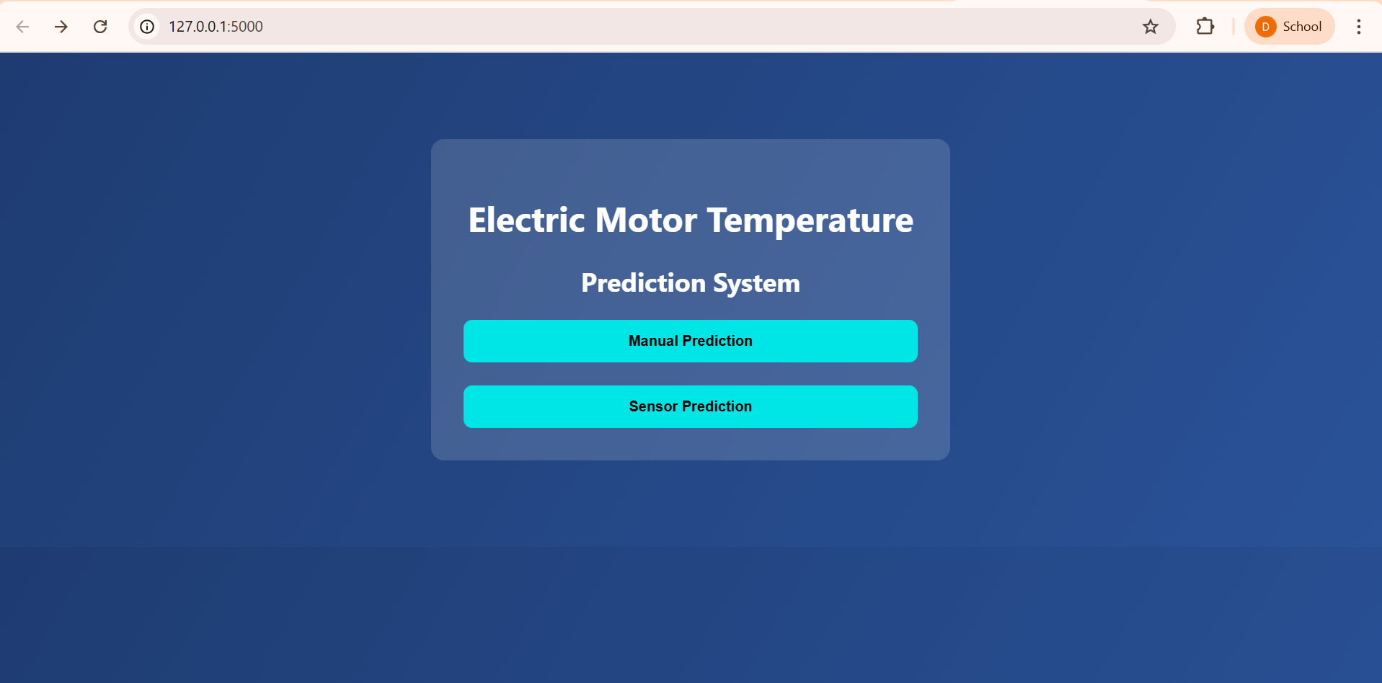

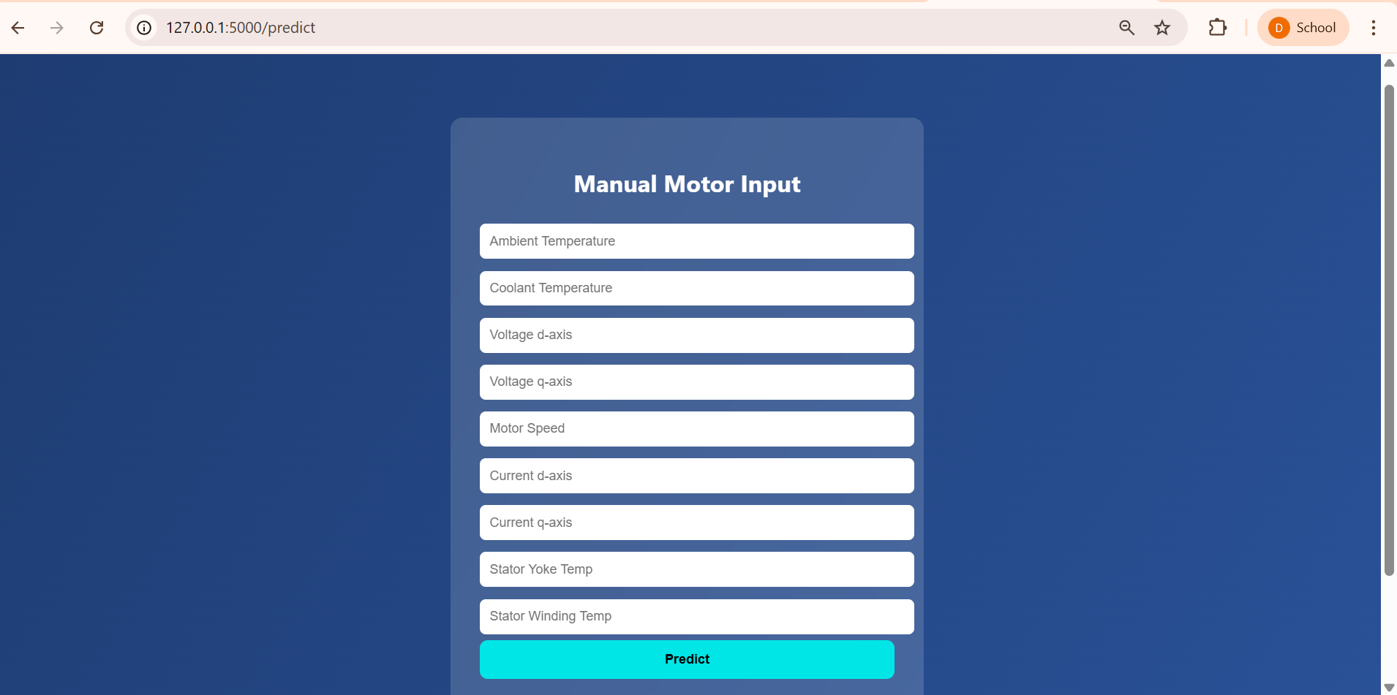

Technologies & Tools Used:
- Python
- Machine Learning Algorithms (Regression Models)
- Pandas & NumPy (Data Processing)
- Scikit-learn (Model Building)
- Matplotlib & Seaborn (Visualization)
- Jupyter Notebook / VS Code

Learning Outcomes:
- Understanding of machine learning regression techniques
- Experience in data preprocessing and feature engineering
- Model evaluation and performance optimization
- Data visualization and interpretation skills
- Practical knowledge of predictive maintenance systems

Conclusion:
The Electric Motor Temperature Prediction System provides an intelligent and automated approach to monitoring motor health. By predicting temperature using machine learning models, the system helps prevent overheating issues, improves equipment lifespan, and supports data-driven maintenance strategies. This solution demonstrates the practical application of AI and Machine Learning in industrial monitoring and smart manufacturing environments.

